Number Plate Detection of Vehicles

## 1. Introduction

Number plate detection is a computer vision technique used to identify and extract license plate information from images or video streams. It's widely used in traffic surveillance, toll systems, and parking automation.

Large Language Models (LLMs) are advanced AI models trained on massive text data to understand and generate human-like text. Examples include GPT-4, BERT, and LLaMA.

While LLMs are not directly used in detecting number plates from images, they can support the pipeline through:

* - Post-processing OCR results
* - Interpreting ambiguous results
* - Automating reports, logs, or summarizing image content

### Uses in Current Trends

* - Automated toll collection
* - Traffic law enforcement
* - Parking systems
* - Intelligent transportation systems

### Future Scope

* - Real-time number plate recognition in autonomous vehicles
* - Integration with AI for behavior prediction and law enforcement
* - Enhanced multilingual plate recognition using multimodal AI

## 2. Problem Statement

The objective of this project is to develop an automated system for detecting vehicle

number plates using computer vision techniques. Manual identification of vehicle

plates is time-consuming, labor-intensive, and prone to human error. Automating this

process can significantly improve efficiency, accuracy, and reliability in various

applications such as law enforcement, parking management, and toll collection.

The primary goals of this system include:

• Detecting number plates from images of vehicles captured in different

environments and lighting conditions.

• Extracting number plate regions accurately while handling challenges like

occlusions, varying backgrounds, and different plate formats.

• Applying Optical Character Recognition (OCR) to extract the alphanumeric text

from the detected plates.

• Deploying the system as a user-friendly web application for real-time

processing.

This project detects number plates in images using OpenCV and reads the plate numbers using EasyOCR.

### Objective

To build a simple, accessible, and effective number plate recognition system using open-source libraries.

## 3. Existing System Limitations

* - Rule-based and hardware-dependent
* - Low performance under poor lighting or low resolution
* - Poor generalization across countries/regions
* - Limited multilingual or style support

## 4. Proposed System

* - Uses Haar Cascade Classifier for plate detection
* - OCR using EasyOCR with multilingual support
* - Adaptable to various number plate styles
* - Extensible with LLMs for post-processing and automation

## 5. Pipeline of the System

### Module Flow:

1. 1. **Data Collection**

* - Dataset: User-provided image or video feed (e.g., `NUMPLATE.jpeg`)

1. 2. **Preprocessing**

* - Convert image to grayscale

1. 3. **EDA (Exploratory Data Analysis)**

* - Analyze images for plate visibility, clarity, and formats

4. **Training**

* - No deep training required; uses pre-trained Haar Cascade and EasyOCR

5. **Testing**

* - Apply on test images to validate accuracy

6. **Implementation**

* - Python script with OpenCV and EasyOCR

7. **Loss Evaluation**

* - Evaluate based on OCR accuracy and detection precision

8. **Coding**

* - Main logic implemented in `detect_number_plate.py`

Coding

       pip install opencv-python easyocr

import cv2

import easyocr

from google.colab.patches import cv2_imshow # Import cv2_imshow

# Load the image

image_path = 'np1.webp'  # Replace with your image

image = cv2.imread(image_path)

# Load Haar cascade for number plate detection

plate_cascade = cv2.CascadeClassifier('haarcascade_russian_plate_number.xml')

# Convert image to grayscale

gray = cv2.cvtColor(image, cv2.COLOR_BGR2GRAY)

# Detect plates

plates = plate_cascade.detectMultiScale(gray, scaleFactor=1.1, minNeighbors=4)

# Initialize OCR reader

reader = easyocr.Reader(['en'])

# Loop through detected plates

for (x, y, w, h) in plates:

    plate_img = image[y:y+h, x:x+w]

    cv2.rectangle(image, (x, y), (x + w, y + h), (0, 255, 0), 2)

    # OCR

    result = reader.readtext(plate_img)

    for detection in result:

        text = detection[1]

        print("Detected Plate Text:", text)

        cv2.putText(image, text, (x, y - 10), cv2.FONT_HERSHEY_SIMPLEX, 1, (0, 0, 255), 2)

# Show result

cv2_imshow(image) # Use cv2_imshow instead of cv2.imshow

cv2.waitKey(0)

cv2.destroyAllWindows()

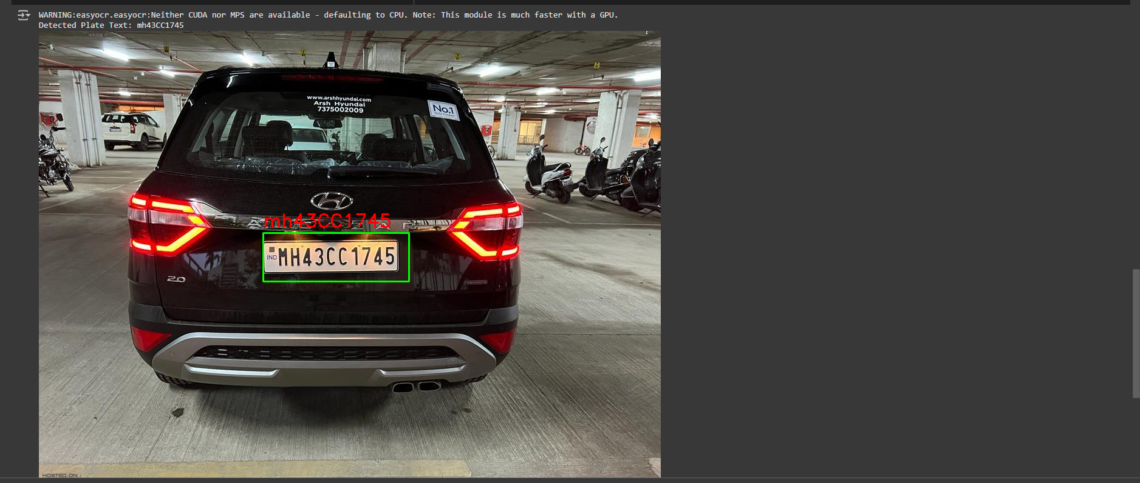

## 6. Dashboard / User Interface

### Streamlit Integration (Optional Enhancement)

* - Upload image interface
* - Display detected plate image
* - Show OCR result
* - Download logs/results

## 7. Libraries and Architecture

### Libraries Used

* - `opencv-python`: For image processing
* - `easyocr`: For text detection and recognition
* - `numpy`: Matrix operations
* - `streamlit`: (Optional UI)

### Architecture

* - Rule-based detection with pre-trained Haar Cascades
* - OCR with EasyOCR (CNN + RNN based)
* - LLMs can be optionally integrated for interpreting results or generating reports

Your system architecture combines **traditional computer vision** with **OCR (Optical Character Recognition)**, and optionally can be enhanced with **LLMs (Large Language Models)**. It has three primary components:

**1. Number Plate Detection (OpenCV – Haar Cascade Classifier)**

**Architecture:**

A **cascade classifier** works by applying multiple stages (layers) of simple features that reject non-plate regions quickly.

It uses **Haar-like features** and **AdaBoost** to select key features for classification.

**Layers:**

**Grayscale Conversion**: Simplifies the image to a single channel.

**Integral Image**: Speeds up feature calculation.

**Stage Classifiers**: A series of decision trees that analyze rectangular regions in the image.

**Cascade Filtering**: Only regions passing all stages are considered as a number plate.

**Limitation**: Haar Cascades are rule-based and can be less accurate than CNNs or YOLO for detection.

**2. Text Recognition (EasyOCR – Deep Learning-Based OCR)**

**Architecture:**

EasyOCR internally uses a deep learning model built on:

**CRNN (Convolutional Recurrent Neural Network)**

**Layers:**

**Convolutional Layers (CNN)**

Extract spatial features from image regions (like strokes and edges of characters).

**Recurrent Layers (BiLSTM)**

Capture sequential dependencies in the extracted text regions.

Handles varying text lengths and orientations.

**CTC (Connectionist Temporal Classification) Loss Layer**

Maps the predictions to character sequences without needing aligned labels.

**Strength**: Works well for multi-language OCR, handwritten and stylized text.

**3. Optional: Integration with LLMs (like GPT)**

**Use Cases:**

Post-processing OCR results

Error correction in text

Contextual understanding (e.g., filtering valid plate formats)

Generating reports or summaries

**LLM Architecture (e.g., GPT):**

Based on Transformer architecture

Multi-Head Self-Attention

Feedforward Neural Networks

Layer Normalization

Positional Encoding

**Note**: In your current project, LLMs are not used directly in detection, but they can be a powerful extension for intelligent text analysis.

**Summary of the Flow**

[Input Image]

↓

[Preprocessing with OpenCV]

↓

[Haar Cascade Plate Detection]

↓

[Cropped Plate Region]

↓

[EasyOCR (CNN + RNN + CTC)]

↓

[Detected Text]

↓

(Optional) [LLM Analysis or Dashboard Display]

## 8. Project Limitations

* - Struggles with poor-quality or night-time images
* - Haar Cascades are not as accurate as deep learning models
* - EasyOCR might misread plates under occlusion or blur

## 9. Future Enhancements

* - Replace Haar Cascade with YOLO or SSD for plate detection
* - Train a custom OCR model with higher accuracy for local license formats
* - Use LLMs for intelligent report generation or anomaly detection
* - Implement multilingual plate support
* - Streamlit or web dashboard for real-time monitoring

## 10. Conclusion

This project offers a foundational number plate recognition system using OpenCV and EasyOCR. It’s easy to implement, adaptable for learning purposes, and serves as a base for more sophisticated solutions that integrate deep learning or AI-powered analytics.